**Chapter-1**

**Study of Existing system and system requirements.**

**Hardware & Software Requirement:**

**Hardware Interfaces**

* Minimum Hardware requirement
* Processor: P4 3.0 GHz
* RAM:1 GB or Higher
* Monitor
* Mouse
* Hard disk: 80 GB

**Software Interfaces**

* Minimum Software requirement
* Java (JSP and Servlet)
* Apache Tomcat Server

All these types of software automatic configure inside operating system after installation it having Java, MYSQL, Apache and operating system base configuration file, it doesn’t need to configure manually.

Introduction

Today, as we are living in uncertainty, what may happen tomorrow no one knows, whether it is related to our health or the objects around us that we use in our daily life. So, why not take Insurance. Insurance is all about providing financial safety to the individual. It helps us to enjoy financial security. If we have a proper application to access all the Insurance related activity then it will be cheery on top. So, Insurance Management System provides us all the functionality.

In this web application, there are majorly two roles, one is that of Admin and another one is that of the customer. Admin is the main role, whose responsibility is to view the user list, add a new category of Insurance, the subcategory, and to make a policy, etc. Another role is that of the User who will be the customers who are going to buy the policy.

This application will not only help the policy maker but also the big to customer where they can buy the policy of their choice.

Objective

The main objective is to build a secured, robust Insurance Management system where the policies are managed properly. All the Information of user, their policy, category of Insurance is maintained on a single platform.

The flow of this project is like the Admin add all the Policy and Customer who is the buyer here can buy the policy of their choice. This application is a developer to support all kinds of functionality that an Insurance Management system should have.

Here, the Admin who is the main user of this application whose responsibility is to keep the record of all users, add a new category of Insurance, add a sub category, add Policy under category, Accept or reject buyers request for policy. The other role is that of customers whose responsibility is to buy the policy from the policy lists. Also, can view the policy he/she holds.

Methodologies

There are two main users of this application. One is the Admin whose responsibility is to manage categories and policies and another role is that of the customer who will buy the policy.

**1) Admin**

* Admin can VIEW the User list.
* Admin can ADD/VIEW/UPDATE/DELETE Category.
* Admin can ADD/VIEW/UPDATE/DELETE Sub-Category.
* Admin can ADD/VIEW/UPDATE/DELETE Policy.
* Admin can VIEW/ACTIVATE/CANCEL the buyers’ policy request.

**2) Customer**

* Customers can VIEW the list of Categories.
* Customers can VIEW the list of Sub-Categories.
* Customers can apply for a Policy.
* Customer can VIEW the list of Policy he/she holds.

**Chapter-2**

**System Analysis**

**2.1 E R DIAGRAM**

**Data Flow Diagram (DFD)**

**Level 0:**

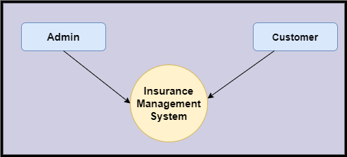

**Level 1**

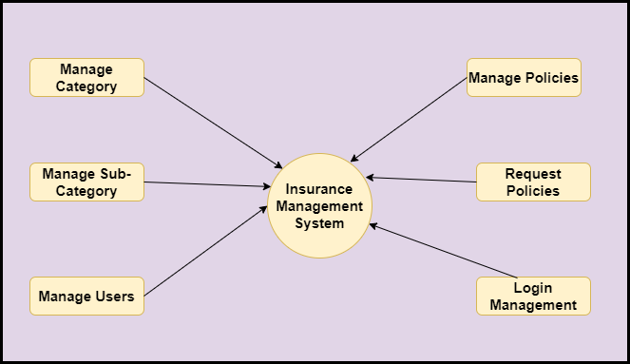

**Level 2-DFD Admin**

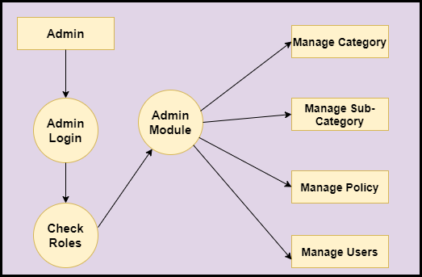

**Level 2-DFD Customer**

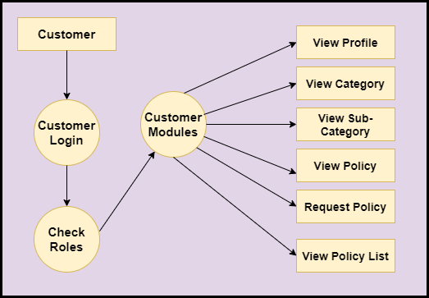

**Feasibility:**

This project will be developed on computer, so first check whether the technology is technically available or not. Now a day’s computer interaction with any job becomes common for any kind of job or work.

And because of increasing usage of Computer, Computer is also available with a variety of hardware. Vendors can fulfill any type of hardware requirement. The whole project is developed by some special tools or by using languages and databases, which are also available in a variety.

Preliminary investigation of a system examines the feasibility of a system that is useful to an organization. It is the first phase of system development.

The main objective of this phase is to identify the current deficiencies in the user’s environment and to determine which existing problem are going to be solve in proposed system and also which new function needs to be added in proposed system.

An important outcome of such preliminary investigation is to determine whether the system that will meet all needed requirements.

Thus, three tests are carried out on the system namely operation, technical and economical.

Any project is beneficial if and only satisfies the organization requirement. For any new system setup, it only meets to be communicated and work the other supporting system.

The new system meets all existing operations since it provides right information at a right time to the right user. A Leigh man can easily operate with the system.

Technical Feasibility examines whether the technology needed is available and if it is available then it feasible to carry out all project activities.

The technical needs of a system include:

* The facility to produce outputs in a given time.
* Ability to process large number of transaction at a particular speed.
* Giving response to users under certain conditions.

The technology needed for our system is mainly:

* Latest version of browsers.
* Any operating system.

These technologies are available which helps to carry out the system efficiently.

Economical feasibility of a system examines whether the finance is available for implementing the new system and whether the money spent is recoverable the satisfaction.

The cost involves is in designing and developing a good investment for the organization.

Thus, hardware requirements used for proposed system are very standard. Moreover, by making use of proposed system to carry out the work speedily will increase and also saves the valuable time of an organization.

In the proposed system the finance is highly required for the installation of the software’s which can also be recovered by implementing a better system.



**Chapter-3**

**Design**

**System Flow Chart:**

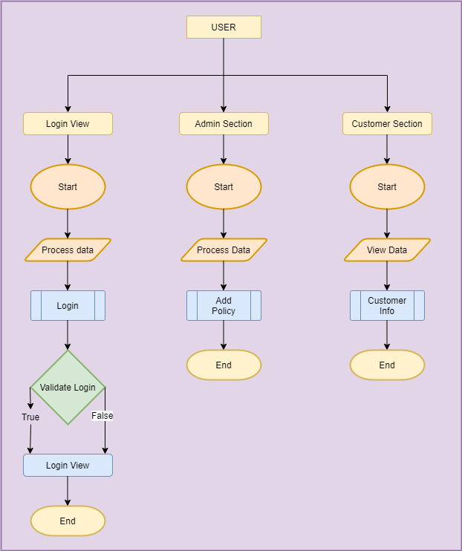

**Data dictionary**

**Data validation:**

Procedures are designed to detect errors in data at a lower level of detail. Data validations have been integrated in the system in almost every area where there is a possibility for the user to commit errors. The system will not recognize invalid data.

Whenever an invalid data is keyed in, the system immediately prompts the user and the user has to again key in the data and the system will accept the data only if the data is correct. Validations have been integrated where necessary.

The system is designed to be a user friendly one. In other words the system has been designed to communicate effectively with the user. The system has been designed with pop up menus.

**Different Type Of validation:**

* Data type validation;
* Range and constraint validation;
* Code and Cross-reference validation; and

Structured validation

**Coding**

**Implementation and Testing:**

**Black-Box Testing**:

Black Box Testing, also known as Behavioural Testing, is a software testing method in which the internal structure/ design/ implementation of the item being tested is not known to the tester. These tests can be functional or non-functional, though usually functional.

This can be following way:

* Input interfacing
* Processing
* Output interfacing



This method is named so because the software program, in the eyes of the tester, is like a black box; inside which one cannot see. This method attempts to find errors in the following categories:

* Incorrect or missing functions
* Interface errors
* Errors in data structures or external database access
* Behaviour or performance errors
* Initialization and termination errors.

**White-Box Testing:**

White Box Testing ,also known as Clear Box Testing, Open Box Testing, Glass Box Testing, Transparent Box Testing, Code-Based Testing or Structural Testing is a software testing method in which the internal structure/ design/ implementation of the item being tested is known to the tester.

The tester chooses inputs to exercise paths through the code and determines the appropriate outputs. Programming know-how and the implementation knowledge is essential.

White box testing is testing beyond the user interface and into the nitty-gritty of a system.

This method is named so because the software program, in the eyes of the tester, is like a white/ transparent box; inside which one clearly sees.

**Limitations and Future Application of the Project**

**Futures Enhancement:**

* In future we can expand this project on the web.
* In future, we can make add agent module in the project.

**Limitation :**

In this, we can’t send email to employee for the renewals of policy..

**Screen Snapshot**

**Conclusion**

Insurance Management System Application helps us to keep the track of category of insurance, policies on a single platform. The Project is developed to support all kinds of customers. With the help of this application, customer can buy the policy easily.

Admin can reject the request of policy from the client if he founds no proper Information. So, security is maintained here.

This application is designed in such a way that any future modification can be done most easily.